1. Signup With Github.com [GitHub](https://github.com/)

Note : gmail email & pass set karo

1. Login

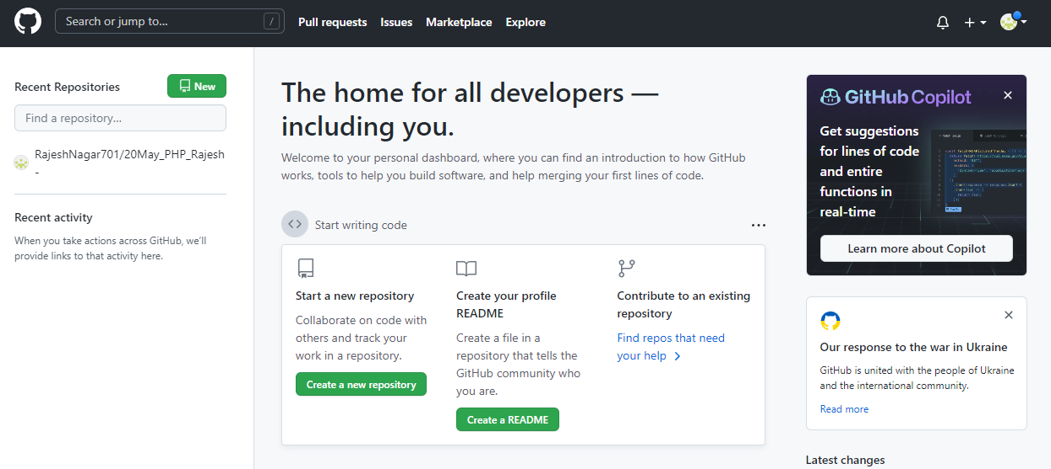

1. Download git bash <https://git-scm.com/downloads>

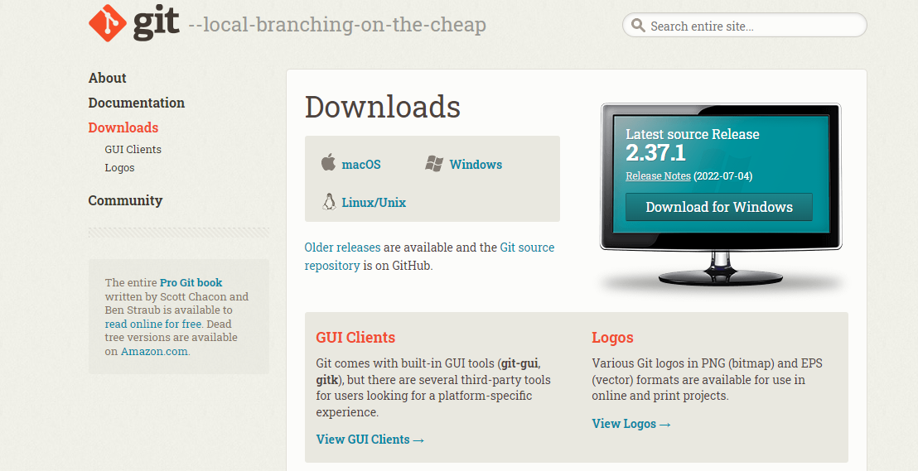

1. Create Repository

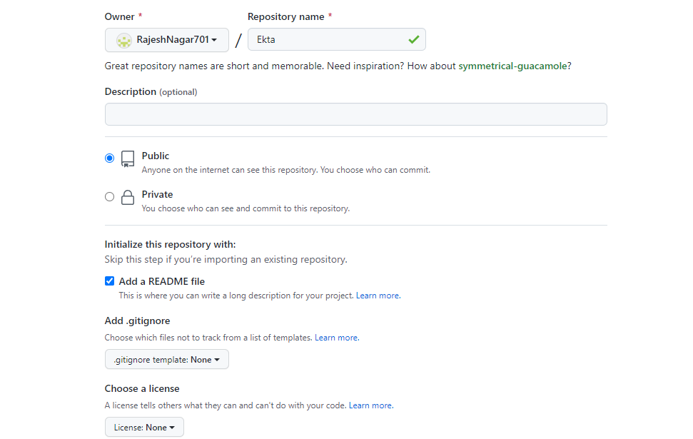

1. Upload data on Repository

Open folder which you want to upload

Right click & open with

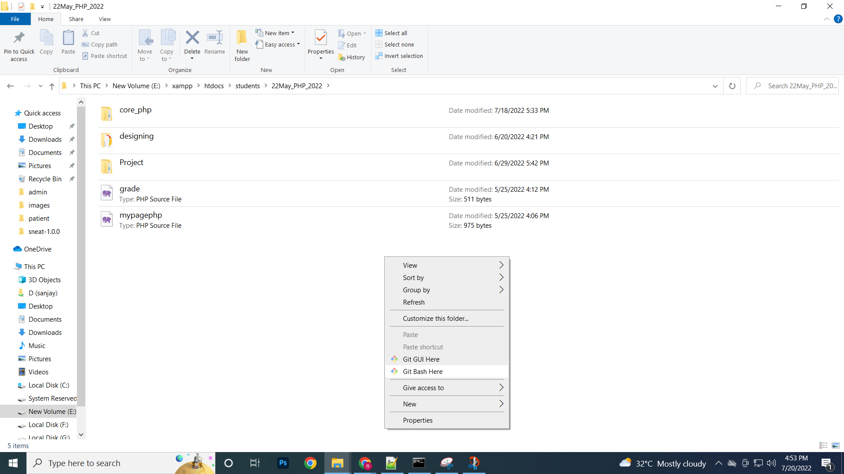

**1)git init**

**2)git add .**

**3)git commit -m "first commit"**

Error : who are you

git config --global user.email “[rajeshnagar.tops@gmail.com](mailto:rajeshnagar.tops@gmail.com)”

git config --global user.name “RajNagar”

**again => git commit -m "first commit"**

**4)git remote add origin** [**https://github.com/RajeshNagar701/20May_PHP_Rajesh.git**](https://github.com/RajeshNagar701/20May_PHP_Rajesh.git)

**5)git push –u origin master**

**If any changes then again save**

1)git add .

2)git commit -m 'updated'

3)git push -u origin master

If want to open & work online server open vs code

Open vs code

https://vscode.dev/

Terminal => new Terminal

git add .

git status

git commit -m 'changed'

git push origin master